Abstract: To structure the abstract, use the same terms used to break the text into sections. The Abstract should not include abbreviations.

Introduction: This section should state the relevance and background to the study, its rationale and main objectives. Please note that only common abbreviations should be used in the main text, which should be explained at first use.
A challenge during the initial evaluation of the poisoned patient is to prognosticate the severity of an ingestion from incomplete. Admitting poisoned patients to the intensive care unit (ICU) who do not require that level of care delays the care of those poisoned patients need and reduces ICU capacity for other patients. For example, admitting all ingestions of more than 450 mg of bupropion to the ICU for 24 hours to observe for ventricular dysrhythmias, leads to approximately 2,000 unnecessary ICU admissions across the United States each year¹. (place for continued references to all those studies showing high # of admits but low # of deaths; not sure how many to use to make the case).
A clinical decision support tool would help guide emergency physicians in selecting the level of care for poisoned patients and in standardizing recommendations from medical toxicologists. It is difficult to make one tool that accurately risk-stratifies the variety of physiological derangements that poisoned patients can have. [Poison Severity Score]
Something here about need for better discrimination.
Medical toxicologists in the Netherlands developed INTOXICATE, a clinical decision support tool to help physicians determine whether poisoned patients required ICU admission or could be safely managed on a general medical floor². INTOXICATE identified easily obtainable clinical covariates as predictors of ICU requirement (defined as mechanical ventilation and/or vasopressors in the first 24 hours of ICU stay, or death at any point during hospitalization) in patients who were admitted to the ICU and received a diagnosis of intoxication. INTOXICATE was internally validated by resampling and correctly identified 34% of ICU patients who did not ultimately require ICU-level care. If applying INTOXICATE has a similar effect in the American healthcare system, it would simultaneously improve the care of poisoned patients and increase access to the ICU.
This outcome, however, assumes INTOXICATE would only be applied to patients who would otherwise have been admitted to the ICU. It remains unclear how having access to such a tool would change clinical decision making. For such a tool to have use in reducing ICU admissions, it must not only be externally valid, but also demonstrate sufficient specificity such as to not bias practitioners to admit patients who do not need ICU admission and would not have been admitted in the absence of a positive score.
The goal of this study was to externally validate INTOXICATE in as a clinical decision tool for the emergency physician or bedside toxicologist to use in the initial evaluation of a poisoned patient.
[We considered 2 use cases: 1 down-triaging those recommended by tox for the ICU (2) all ED comers]
Methods:
Setting
We conducted a retrospective study of toxicology consultations at one urban tertiary care center with a 24/7 bedside toxicology service. We screened all consultations from from January 2023 to April 2024. We included patients aged 12-18 even though the original study did not and analyzed them as a distinct subgroup. We included adolescents because they comprise X% of our consultations and Y% of nationwide calls for intentional ingestions and have comparable cardiovascular and neurological responses to xenobiotics. We excluded patients younger than 12 and those with missing data.

Definitions
INTOXICATE assigns each patient a score, the INTOXICATE Risk Score (IRS) based on certain clinical features. For example, a patient receives 1 point if the heart rate is between 75 to 85 beats per minute and 2 points if between 85 to 95 beats per minute. The sum of the scores across all clinical features is the IRS. We refer the reader to (1) for detail on calculating IRS.

We did not distinguish between discharge from the Emergency Department and transfer from the Emergency Department to Psychiatry.

Statistical analyses
Our outcome measure was the inter-rater reliability between the INTOXICATE’s prediction disposition and the treating physician's decision. We chose this measure instead of overall agreement to capture the degree to which INTOXICATE agrees with toxicologist decision-making beyond chance.

Results:
Description of Data Set. We screened 112 patients, excluding 7 who were under 12 and 2 who had missing data, ultimately including 103 patients for analysis (Figure 1). The median age of the adolescents and adults were, 15 [14-16] and 35 [28-50], respectively, expressed as median [interquartile range], respectively. The proportions of admission to a general medical floor or the ICU were comparable between the age groups (Table 1).
Of the remaining 110 patients, 21 (19%) were admitted to the ICU, 16 (14%) to a general medical floor, and 75 (68%) were discharged or transferred directly to psychiatry. INTOXICATE recommended ICU admission for 14/21 (67%) of patients for whom the toxicologist recommended ICU admission, ICU admission for 12 of the 16 (75%) patients for whom admission the toxicologist recommended a general medical floor, and ICU admission for and 37 of the 44 (84%) patients for whom the toxicologist recommended discharge. No patients for whom toxicology recommended a floor admission were admitted to a floor and then transferred to the ICU. No patients who were discharged but for whom INTOXICATE recommended admission returned to any hospital in the metropolitan area in 48 hours.
Agreement between bedside toxicologist and INTOXICATE. There was no agreement greater than chance between INTOXICATE’s predictions and the bedside toxicologists’ recommendations for either adolescents or adults (Table 2).
Adults. Of the 79 adults, 16 were admitted to the ICU. INTOXICATE and toxicologist agreed that 11 of the 16 (69%) required ICU admission. For the remaining 5, INTOXICATE assigned them a lower risk score because the exposure was lower risk, there was no respiratory insufficiency or dysrhythmia, their GCS scores were 15, their pulses were lower and they were younger. The median (IQR) pulse in those for whom INTOXICATE and Toxicology recommended ICU admission was 87 (76-104) beats per minute. It was 70 (65-74) beats per minute in the patients for whom Toxicology recommended ICU admission but INTOXICATE did not. The median ages were 38 (30-53) and 30 (25-38), respectively. None of these differences were statistically significant. Taking the toxicologist’s recommendation as the gold standard, the sensitivity and specificity of INTOXICATE were 69% [41-89] and 38% [26-51], respectively, expressed as estimate [95% confidence interval].
INTOXICATE thought 39 people required the ICU because of the converse even though bedside toxicologists did not. The age, median heart rate, and median systolic blood pressure were not significantly different between those for whom INTOXICATE predicted required the ICU and those whom it predicted did not.
Adolescents.
There were no statistically significant differences between adolescents and adults in gender, heart rate, actual disposition, respiratory insufficiency, cirrhosis, dysrhythmia, GCS, type of exposure, or other medical reasons for ICU admission. The systolic blood pressure was significantly different, 116 [106-119] and 120 [112-140], respectively, but this difference is not clinically meaningful. Of the 24 adolescents, 4 were admitted to the ICU. INTOXICATE and toxicologist agreed that 2 of the 4 (50%) required ICU admission. Both these patients presented with lowered GCS, tachycardia, and a dysrhyrhmia. One presented after ingesting an unknown substance. Of the two patients, for whom INTOXICATE did not recommend ICU admission, one presented with a toxic acetaminophen ingestion. INTOXICATE assigned a risk score of 3 because the patient was normotensive, not tachycardic and had no cirrhosis, respiratory insufficiency, or cardiac dysrhythmia. The other presented with alcohol intoxication and was hypertensive, tachycardic, and dysrhythmic with GCS = 10 (IRS = 4). INTOXICATE recommended the ICU requirement for 9 patients for whom toxicology did not. These 9 patients presented with different ingestions, but all were tachycardic with mean 113 (106, 115) bpm, all were dysrhythmic, and all had GCS of 15. There were no significant differences in age, HR, SBP, GCS, or presence of respiratory insufficiency, cirrhosis, dysrhythmia, or other reason for ICU admission. Taking the toxicologist’s recommendation as the gold standard, the sensitivity and specificity of INTOXICATE were 50 [1-99]% and 55 [33-77]%, respectively, expressed as estimate [95% confidence interval].

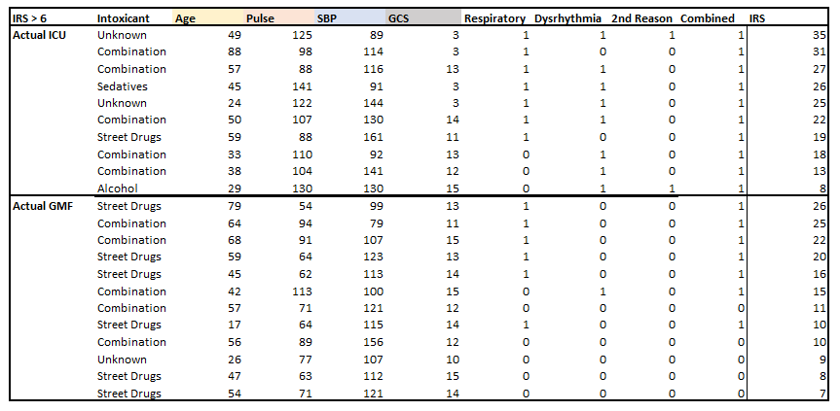
Covariates contributing to IRS for all patients recommended for ICU treatment by a positive IRS score (>6). Dichotomous variables are encoded as 1 = true, 0 = false.

Discussion:
The overall goal of this paper was to externally validate INTOXICATE as a clinical decision tool in the initial evaluation of a poisoned patient. We found that INTOXICATE had no clinically significant agreement with the recommendations of bedside toxicologists.
There are methodological differences between our study and the initial derivation study. The initial derivation study investigated suspected poisoned patients admitted to the ICU. Our study population was suspected poisoned patients who presented to the ED. We chose this population because it represents the population for whom the rule is most likely to be used.
If applied only to patients for whom toxicology recommended ICU admission, INTOXICATE would have reduced ICU admissions by 33% (7/21), consistent with the initial derivation study. However, INTOXICATE recommended ICU admission for 49 of 60 patients for whom toxicology recommended a admission to a general medical floor, discharge, or transfer to Psychiatry directly from the Emergency Department. This would have increased ICU utilization by around 200% (from 21 to 44). We note that these findings are limited by our small sample size.
We found no more than chance agreement between INTOXICATE and the toxicologist at bedside, suggesting that the two approaches ratiocinate differently. The bedside toxicologist may consider features INTOXICATE does not, such as clonus, abnormal EKG intervals, progressive limb swelling, in ability to tolerate food or liquid by mouth, or acidemia.
Variation in practices across health care systems may contribute to the discordance. At the authors’ institution, all patients receiving an N-acetylcysteine infusion or hyperbaric treatment are admitted to the ICU. The agreement between INTOXICATE and the initial disposition may change in health care systems that use a Poison Center-based Toxicology consultation, rather than a bedside one. The degree of evaluation and treatment done in the Emergency Department may vary across healthcare systems.
Our study did not investigate all facets of INTOXICATE. INTOXICATE identifies predictors of not needing ICU care, such as acute intoxication with alcohol. In our cohort, Toxicology was not consulted on any patients with alcohol intoxication alone. INTOXICATE identifies respiratory insufficiency, dysrhythmia, cirrhosis, and a nontoxicological reason for ICU admission as predictors of needing ICU care. In this study, all patients admitted to our ICU had either respiratory insufficiency, dysrhythmia, or both. However, 7/19 patients safely (would need to know the actual outcomes of hospital stay to say safely, but I’m presuming it at the moment) recommended for GMF for discharge by toxicology had one of the above comorbidities, INTOXICATE recommended ICU for all patients with any of the above criteria, suggesting that INTOXICATE is not better than toxicology for the purpose of ICU rule-outs in patients with significant comorbidities.
The IRS threshold of 6 points that was chosen by Brandenburg et. al. to minimize false negatives. [Develop]
INTOXICATE had a specificity of 36.2% in the initial study and 38% [26-51] in ours. This specificity may not reduce unnecessary ICU admissions when applied to the US ED population. While there have been risk models developed with mortality as an outcome, both for the general patient population and specifically for intoxicated patients (cite cite cite), these have generally been designed as prognostic tools for use in the ICU, and their use as predictors of an uneventful ICU course from the ED has not been evaluated. The strength of INTOXICATE is that it was modelled with ICU requirement, rather than in-hospital mortality, as an outcome, appropriate for resolving the unique issue of disproportionately uneventful ICU courses in intoxicated patients. With this strength, however, there are also weaknesses to a model intended for use in an ED cohort but developed on data from an ICU cohort. Here I would write something about our results with changing the threshold, and the associated risks of false negatives, though I’ll wait until I have the most up-to-date patient list for this step.

Another potential limitation of INTOXICATE is the usage of APACHE IV diagnoses for classification of intoxicant, which was the only indication of intoxication type available to Brandenburg et. al. in their model development cohort. Antidepressants, for example, is the diagnosis given to an intoxication with any type of antidepressant, including SSRIs, tricyclics, lithium, and others, all of which have potentially different mechanisms of toxicity. A category is given for analgesics, presumably pharmaceuticals, however intoxication with opiates produced as drugs of abuse would be classified as a street drug, along with cocaine and amphetamines. A category is included for CO, As, or CN, but intoxications with other poisons, such as those found in household products or industrial settings, would presumably fall under toxins not otherwise specified. The category combination of two subtypes of intoxication serves as a catch-all for polysubstance intoxications, however this would fail to identify polysubstance intoxications in patients with two or more mechanistically different intoxicants within the same APACHE IV classification, and Brandenburg (for reasons unknown and not explained in their paper) did not include polysubstance intoxication as a covariate in their model or assign it a risk score. This is particularly important given the significant morbidity and mortality associated with polysubstance intoxications, being implicated in 48-58% of overdose deaths (cited Peppin below, but will find more because that source is specific to unintentional drug overdose and there is definitely plenty more to cite and mention). Accounting for polysubstance intoxication in clinical prediction models poses the additional challenge of frequently incomplete or inaccurate reporting of intoxicant by patients and collateral sources. (I’ll try to find a source for how many patients present with unknown intoxication type later). We note that for 18/28 of intoxicated patients in our ED cohort, intoxication type was classified as Intoxicant NOS or Combination, with all but one of the remainder being classified as Street drug.

It may be worth finding out what happened to the 7/21 patients who were admitted to the ICU but for whom INTOXICATE recommended GMF, particularly whether they ultimately required ICU-level care. It would be concerning if INTOXICATE was ruling out the wrong patients.

Conclusions:
A clinical prediction model may demonstrate excellent performance in retrospective validation, but the impact it will have on clinical practice is dependent on when it is chosen for use, how its results are interpreted, and whether its recommendations are accepted. Without instruction, it is unlikely that a practitioner will use a model exclusively or inclusively for patients that would have been selected for inclusion in model development, it is unlikely that all practitioners will place equal weight on the results of a given score, and practitioners may be biased to defer to (and document) the results a clinical prediction model only when it agrees with their own judgement. At this stage, INTOXICATE lacks necessary inclusion and exclusion criteria that would guide its use.
This brings up important questions on the role of clinical decision rules in ICU admission for intoxicated patients. Other commonly used clinical decision rules that recommend some course of action (e.g., Ottawa Knee/Ankle, Wells’ DVT/PE, Canadian Head CT, PECARN) were created to help identify patients who would benefit from an action in cases where the risks associated with the action are low (e.g., diagnostic imaging) and the consequences of a false negative are high (e.g., untreated fracture, thromboembolism, or ICH). When these rules are appropriately applied to patients with reasonable pre-test probability of disease based on H&P, just one or two points are sufficient to communicate sufficiently high risk of an outcome to indicate intervention. In contrast, for INTOXICATE, the problem being addressed by the decision rule is the outcome of the decision rule itself - ICU admission - and a slew of non-specific clinical covariates found to have independent (but not independently sufficient!) associations with the outcome are assessed. At this time, INTOXICATE is an arithmetical substitute for the physician’s gauge of pre-test probability, but is not the test itself. In that way, INTOXICATE is more closely related to a mortality prediction score, such as APACHE, and mortality prediction scores are not clinical decision rules. There’s a lot left that could be written for the conclusion, but I think it’s best to shape up the rest of the paper before I conclude it.
[this should be lasts paragraph] A tenet of INTOXICATE is that the level of care a poisoned patient requires can be prognosticated based on a small number of commonly used clinical features, despite the variety of xenobiotics and their variegated effects on the body. Risk-stratification measures for specific ingestants have been quite successful, for example serum concentrations of acetaminophen, salicylate, bupropion HR(2), PO tolerance for caustics, osmolar gap for toxic alcohols. However, there still is a need for a general prediction rule that clinicians who are not toxicologists can use to determine when to consult toxicology and that toxicologists can use to standardize their recommendations. Our results extend those of Brandenburg by demonstrating that the sensitivity and specificity of INTOXICATE are comparable in the Dutch and American healthcare systems. Our findings underscore the divide between INTOXICATE’s prediction and the recommendation of bedside toxicologists. Future work may improve INTOXICATE by considering trends in vital signs and focusing on ingestions for whom there is no effective risk stratification tool.
Other points to work in
- This paper is totally not finished
- Not yet known whether a mortality prediction score, developed for intoxicated patients or the general population, at a certain threshold is an equal or better predictor of ICU requirement than a model developed on ICU patients with known outcomes

References
- Simpson, M. et al. Clinical and electrocardiographic factors associated with adverse cardiovascular events in bupropion exposures. Clin Toxicol 61, 529–535 (2023).
- Brandenburg, R. et al. The need for ICU admission in intoxicated patients: a prediction model. Clin Toxicol 55, 4–11 (2017).
- Han, K. S., Kim, S. J., Lee, E. J., Shin, J. H., Lee, J. S., & Lee, S. W. (2021). Development and validation of new poisoning mortality score system for patients with acute poisoning at the emergency department. Critical care (London, England), 25(1), 29. https://doi.org/10.1186/s13054-020-03408-1
- Idowu, D., Ezema, K., Corcoran, J., & Farkas, A. (2024). The predictive value of heart rate in determining clinical course after a bupropion overdose. Clinical Toxicology, 1–7. https://doi.org/10.1080/15563650.2024.2347514
- Peppin, J. F., Raffa, R. B., & Schatman, M. E. (2020). The Polysubstance Overdose-Death Crisis. Journal of pain research, 13, 3405–3408. https://doi.org/10.2147/JPR.S295715

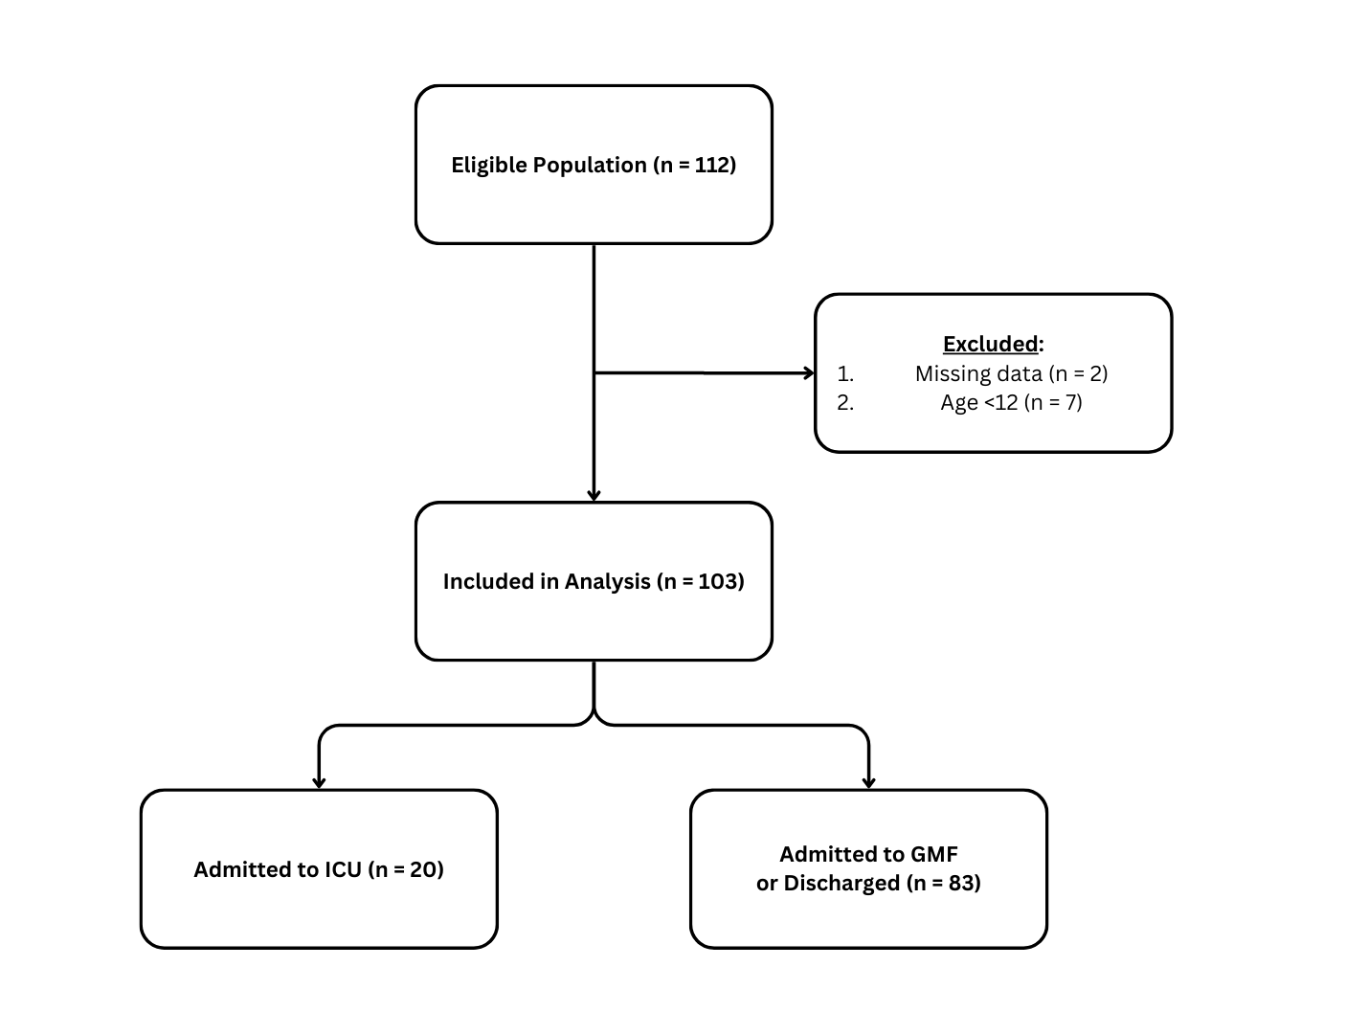
Figure 1. Screening and Inclusion of Patients.

Characteristic | Adolescent, N = 24¹ | Adult, N = 79¹ | p-value²
Age | 15 (14, 16) | 35 (28, 50) | <0.001
Gender |  |  | 0.2
F | 13 (54%) | 40 (51%)
M | 10 (42%) | 39 (49%)
NB | 1 (4.2%) | 0 (0%)
Pulse | 99 (89, 110) | 90 (72, 107) | 0.071
SBP | 116 (106, 119) | 120 (112, 140) | 0.033
Actual Disposition |  |  | 0.5
Discharge | 18 (75%) | 49 (62%)
GMF | 2 (8.3%) | 14 (18%)
ICU | 4 (17%) | 16 (20%)
Respiratory Insufficiency | 2 (8.3%) | 16 (20%) | 0.2
Cirrhosis | 0 (0%) | 2 (2.5%) | >0.9
Dysrhythmia | 12 (50%) | 29 (37%) | 0.3
Secondary Reason for ICU Admission | 0 (0%) | 1 (1.3%) | >0.9
GCS |  |  | 0.024
3 | 0 (0%) | 3 (3.8%)
5 | 0 (0%) | 1 (1.3%)
10 | 3 (13%) | 0 (0%)
11 | 0 (0%) | 1 (1.3%)
12 | 0 (0%) | 1 (1.3%)
13 | 0 (0%) | 2 (2.5%)
14 | 3 (13%) | 2 (2.5%)
15 | 18 (75%) | 69 (87%)
Exposure Category |  |  | 0.11
Alcohol | 2 (8.3%) | 5 (6.3%)
Analgesic | 6 (25%) | 11 (14%)
Antidepressants | 5 (21%) | 11 (14%)
CO, As, CN | 0 (0%) | 9 (11%)
Combination | 1 (4.2%) | 16 (20%)
Sedatives | 0 (0%) | 6 (7.6%)
Street Drugs | 5 (21%) | 10 (13%)
Unknown | 5 (21%) | 11 (14%)
¹ Median (IQR); n (%)
² Wilcoxon rank sum test; Fisher’s exact test; Pearson’s Chi-squared test

Table 1. GMF, general medical floor.

 | Adolescent |  |  |  |  | Adult
 | Predicted Disposition |  |  |  |  | Predicted Disposition
 | ICU | Not ICU | Total | Cohen’s kappa | p-value | ICU | Not ICU | Total | Cohen’s kappa | p-value
Actual Disposition |  |  |  | 0.029 | 0.050 |  |  |  | 0.038 | 0.050
ICU | 2 | 2 | 4 |  |  | 11 | 5 | 16
Not ICU | 9 | 11 | 20 |  |  | 39 | 24 | 63
Total | 11 | 13 | 24 | 0.029 | 0.050 | 50 | 29 | 79 | 0.038 | 0.050

Table 2. Cohen’s

 | Toxicologist’s Recommendations
 | ICU |  | Not ICU
 | INTOXICATE’s Recommendations |  | INTOXICATE’s Recommendations
 | ICU, N = 11¹ | Not ICU, N = 5¹ | ICU, N = 39¹ | Not ICU, N = 24¹
Respiratory Insufficiency | 6 (55%) | 2 (40%) | 7 (18%) | 1 (4.2%)
Cirrhosis
Yes | 0 | 0 | 2 (5.1%) | 0
Dysrhythmia | 5 (50%) | 1 (20%) | 22 (56%) | 1 (4.2%)
Secondary Reason for ICU Admission
Yes | 1 (9.1%) | 0
No |  |  | 39 (100%) | 24 (100%)
GCS
3 | 3 (27%) | 0 | 0 (0%) | 0 (0%)
5 | 1 (9.1%) | 0 | 0 (0%) | 0 (0%)
11 | 0 (0%) | 0 | 1 (2.6%) | 0 (0%)
12 | 1 (9.1%) | 0 (0%) | 0 (0%) | 0 (0%)
13 | 2 (18%) | 0 (0%) | 0 (0%) | 0 (0%)
14 | 0 (0%) | 0 (0%) | 2 (5.1%) | 0 (0%)
15 | 4 (36%) | 5 (100%) | 36 (92%) | 24 (100%)
Exposure Category
Alcohol | 0 (0%) | 1 (20%) | 1 (2.6%) | 3 (13%)
Analgesic | 1 (9.1%) | 2 (40%) | 2 (5.1%) | 6 (25%)
CO, As, CN | 1 (9.1%) | 2 (40%) | 5 (13%) | 1 (4.2%)
Combination | 3 (27%) | 0 (0%) | 8 (21%) | 5 (21%)
Street Drugs | 3 (27%) | 0 (0%) | 5 (13%) | 2 (8.3%)
Unknown | 3 (27%) | 0 (0%) | 7 (18%) | 1 (4.2%)
Antidepressants |  |  | 6 (15%) | 5 (21%)
Sedatives |  |  | 5 (13%) | 1 (4.2%)
Pulse | 87 (76, 104) | 70 (65, 74) | 101 (80, 115) | 85 (73, 91)
SBP | 113 (91, 149) | 112 (105, 130) | 120 (114, 146) | 123 (115, 129)
Age | 38 (30, 53) | 30 (25, 38) | 47 (34, 59) | 27 (20, 32)
¹ n (%); Median (IQR)

